2.5.3 - IT integration and reforms in the examination procedures and processes including Continuous Internal Assessment (CIA) have brought in considerable improvement in the Examination Management System (EMS) of the Institution.
The Examination Management System of SKR & SKR Govt. College for Women (A), Kadapa is a structured system with SPES Software which brought considerable improvement in the evaluation process to assess the student’s performance. The EMS with Information Technology to fetch fruitful reforms in the examination procedures and processes of both Continuous Internal Assessment (CIA) and Semester End Exams (SEE) and is helpful in attaining learning outcomes with continuous reforms.
. Examination Reforms:
- Implementation of CBCS Pattern from 2015-16, Conferred autonomous status by UGC implemented from the academic year 2017-18 in the college.
- Adopted semester pattern of Curriculum with Continuous internal assessment, Credit/grading system, Student feedback and Self-appraisal by teachers.
- Automation of examination system for improvement in reliability, efficiency, security, transparency, confidentiality and accuracy in the entire procedure of examinations.
- Transparency is ensured for conducting CIA and SEE.
External and Continuous Internal Assessment Modes
The Examination pattern consists of two components, namely, Continuous Internal Assessment (CIA) and Semester End Examination (SEE) with 25:75 weightage. The performance of the students is assessed for 100 marks in each course through CIA and SEE.
Guidelines for Internal Assessment
In order to assess the skills, values and knowledge gained by the student, the concerned faculty member has to conduct an internal assessment.
The internal assessment may comprise of the following:
- All the undergraduate programmes offered by the college are to have specified components for internal evaluation.
  - For example,
    - Essays
    - Tutorials
    - Home Assignments
    - Seminars
    - Presentations
    - Laboratory Work,
    - Unit Tests,
    - Workshop,
    - Project based learning,
    - peer reviews,
    - quizzes, other elements of participatory learning may be used.
- The components of internal assessment are to have a time frame for completion by students with concurrent and continuous evaluation of faculty members. The continuous internal assessment/evaluation has to be conducted by the teacher and the evaluation outcome should be expressed by pre-determined marks or by grades.
- The proportion of Continuous Internal Evaluation (CIA) to External Evaluation (EE) should be specified as 25:75 marks ratio.
Continuous Internal Assessment Evaluation:

- Written Test (Average of 2 Tests each test carries 20 and 15 marks) 35 Marks
- Seminars (Odd Semester) / Study Project (Even Semester) 05 Marks
(In each paper every student should give one seminar and present the copy to
concern department. Study project may be individual or group)
- Assignments 05 Marks
(Every student should submit 5 Assignments in each Course)
- Clean and Green/Attendance 05 Marks
Total 50 Marks Scale down to 25 Internal Assessment Marks

- Retests for CIA will be given only for those students who have missed the tests because of participation in college-sponsored activities such as NCC, NSS, Sports and in the case of serious medical issues. These tests will be held before the commencement of the End Semester examinations.
- For single major courses in I semester the CIA and External examinations for core papers is conducted as per the guidelines of APSCHE i.e., Objective Type questions are given for 75 marks which include (MCQ’s, Match the following. True/False, Fill in the Blanks, One Marks Questions).
- Implementation of Community Service Projects, Internships as per between and scheduled semesters.
- Assessment of Community Service Projects by Internal Assessment Committee.
- After completion of 90 working days, SEE is conducted and declared results within 30 days of the last exam conducted.

MCQ | 20 | 4 Questions from Each Unit
Fill in the Blanks | 10 | 2 Questions from Each Unit
Match the following | 25 | Per Unit 1 Match the Following
True or False | 10 | 2 from Each Unit
One word Answers | 10 | 2 Questions from Each Unit
 | 75

- Reforms in question paper setting as per Bloom’s taxonomy level to maintain academic standards.
- Adopting approved list of Examination panel for paper setting and valuation procedure.
- Preparation of 2 sets of question papers for Maintenance of Confidentiality.
- Senior faculty are nominated as observers during the examination to monitor exams.
- Supplementary examinations are conducted along with regular ODD and EVEN Semester examinations.
- INSTANT examinations are also conducted to final year students to clear up the backlogs of 5th and 6th semesters to facilitate higher education and get placement.
Examination and Evaluation Processes:

- Preparation of Examination calendar as per Academic calendar
- Collection of BOS approved syllabus, Panel of Examiners from department in charges
- Based on the BOS Proceeding and AC approval, the programmes and courses are assigned with codes.
- Registration of the students in the SPES software to prepare attendance sheet for Internal Examinations.
- Scheduling two Internal Examinations for each semester.
- Providing internal award sheet (CIA) and collecting evaluated answer scripts with marks posting award sheets
- Issue of fee notification for registration of examinations
- Call for 2 Sets of Question papers by paper setters through Mail/Post transaction as per Bloom’s taxonomy
- Preparation of Time table for Theory and Practical Examinations
- Practical Examinations should be conducted Internal for ODD Semesters and External for EVEN Semesters (As per A.C resolutions)
- Providing External Examiners for Practical Examinations
- Remaining examination procedure is integrated with SPES Software Examination Management System.

Mechanism For Appointing Examiners:
- The appointment of examiners for each semester shall be made and confirmed before 20 days of commencement of the examination for both theory and practical.
- Only persons having the prescribed qualifications and at least three years of teaching at the appropriate level shall be included in the panel.
- The evaluation of answer scripts, for odd semesters the scripts are evaluated outside the college in any of the evaluation committee decided colleges and for even semesters the evaluation shall be carried out by the panel of examiners within the college.

Automation of Examination cell with SPES Software. “STUDENT PERFORMANCE AND EVALUATION SOFTWARE” enables:
- Students Registration
- Issue of Fee notification
- Generation of Application and Fee Challan
- Fee payment both for Regular and Supplementary is done through Online using any UPI mechanism.
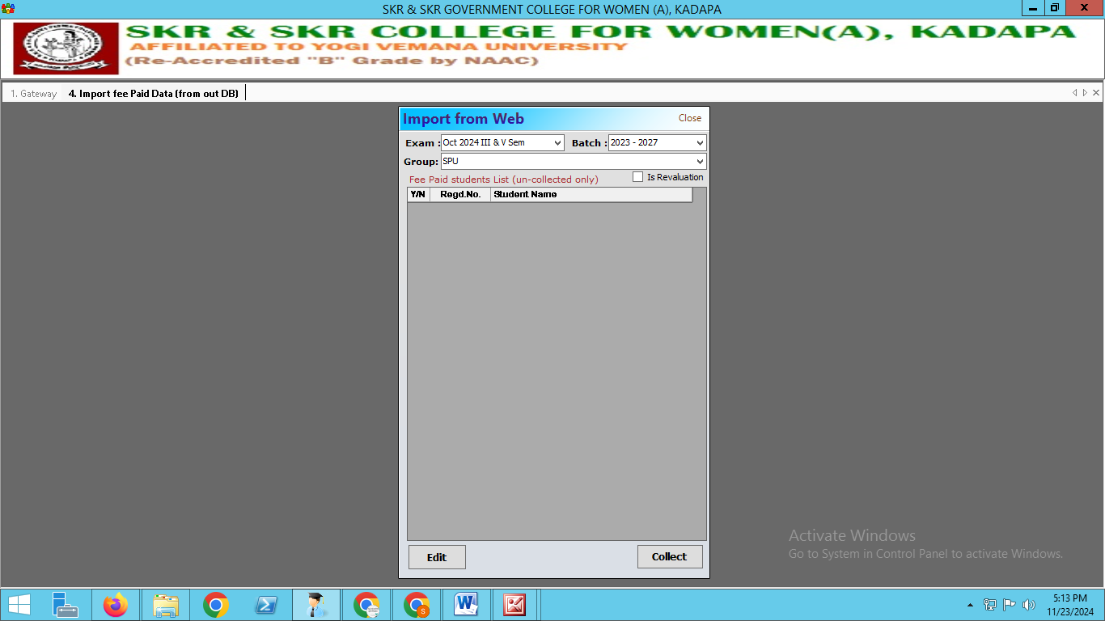

- Hall Tickets are generated in the student login.
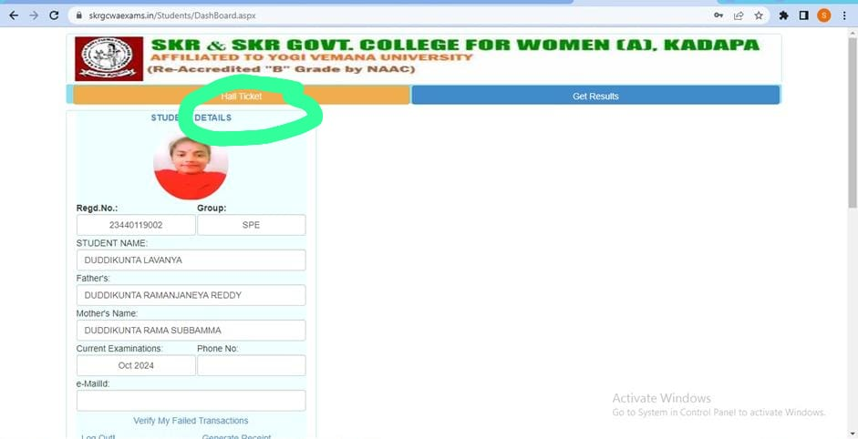
- Generation of Hall tickets
- Printing & Distribution of Hall tickets to the Dept In charges as per Student attendance.
- Question papers Setting for each and every Semester End Exam
- ‘D’ forms generation
- Code numbers generation
- Bundle slips generation
- Award lists generation
- De-coding process
Printing of notice board marks
- Results are released through the examination portal where students can view the results in their login.
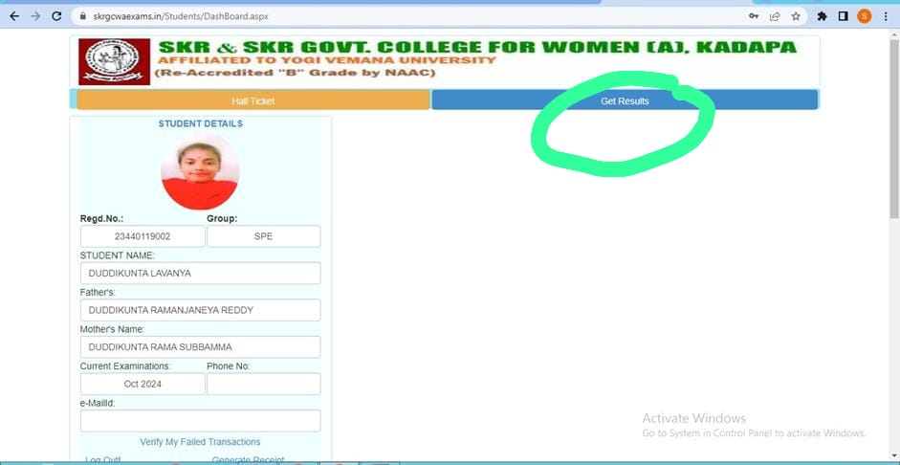
- Student Vs subject pass particulars
- Department wise backlogs information (Internal, External, Practical)
- Tabulation of result
- Printing of Semester end marks memos
- Result analysis.
- The final tabulated result data submitted to affiliating Yogi Vemana University, YSR Kadapa.

